|  |  |
| --- | --- |
|  | **Clinical Applications of Shockwave Therapy: A Comprehensive Overview of**  **ESWT, EMTT, AWT in Regenerative Medicine**  Release Date: 2/10/2025  Expiration Date: 6/30/2026 |

**Activity Overview**

The approved CME content provides a comprehensive overview of Shockwave Therapy (ESWT), Electromagnetic Transduction Therapy (EMTT), and Acoustic Wave Therapy (AWT), detailing their mechanisms and clinical applications in regenerative medicine, sexual health, orthopedics, and aesthetic treatments. Participants will gain a deep understanding of how these therapies enhance tissue regeneration, pain management, and overall patient outcomes, including best practices for integrating them into clinical practice. Through case studies, and evidence-based research, healthcare professionals will learn to apply these advanced modalities effectively, ensuring optimized therapeutic results across various medical fields.

**Target Audience**

This activity is intended to meet the needs of physicians, physician assistants, nurse practitioners, and nurses.

**Learning Objectives**Upon completion of the educational activity, participants should be able to:

* Define the mechanisms and types of shockwave therapy, including Focused Shockwave Therapy (FSW), Radial Shockwave Therapy (RSW), and Acoustic Wave Therapy (AWT), and their clinical applications in regenerative medicine.
* Understand the principles of Electromagnetic Transduction Therapy (EMTT) and its role in deep tissue healing, pain management, and treatment of degenerative conditions such as osteoarthritis and chronic inflammation.
* Explore the regenerative effects of shockwave therapy in orthopedic treatments, sexual health (e.g., erectile dysfunction and Peyronie’s disease), and aesthetic applications (e.g., skin rejuvenation).
* Learn effective protocols for combining shockwave therapy with EMTT and other regenerative modalities to enhance patient outcomes, targeting both superficial and deep tissue healing.
* Implement best practices for patient management, including monitoring, follow-up protocols, and managing patient expectations for optimal
* Evaluate real-world case studies and success stories in regenerative, orthopedic, sexual health, and aesthetic settings to apply shockwave therapy effectively in clinical practice.
* Identify emerging trends and future applications of shockwave therapy in various medical fields.

**Method of Participation**   
In order to receive credit, participants should watch the entire video. Statements of credit will be awarded upon completion of the post-test and online evaluation/claim credit form. If you have questions about this CE activity, please contact AKH Inc. at [lritley@akhcme.com](mailto:lritley@akhcme.com).

|  |  |
| --- | --- |
|  | **CE Credit Provided by AKH Inc., Advancing Knowledge in Healthcare.** |

In support of improving patient care, this activity has been planned and implemented by AKH Inc., Advancing Knowledge in Healthcare and REVIVE™ Advanced Training Consultants. AKH Inc., Advancing Knowledge in Healthcare is jointly accredited by the Accreditation Council for Continuing Medical Education (ACCME), the Accreditation Council for Pharmacy Education (ACPE), and the American Nurses Credentialing Center (ANCC), to provide continuing education for the healthcare team.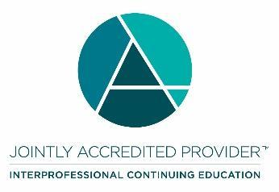

**Physicians**  
AKH Inc., Advancing Knowledge in Healthcare designates this enduring material for a maximum of 2.5 *AMA PRA Category 1 Credit(s)*™. Physicians should claim only the credit commensurate with the extent of their participation in the activity.

**Nurses**

Credit being awarded: 2.5 ANCC contact hours

**Physician Associate**

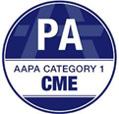AKH Inc., Advancing Knowledge in Healthcare has been authorized by the American Academy of Physician Associates (AAPA) to award AAPA Category 1 CME credit for activities planned in accordance with AAPA CME Criteria. This activity is designated for 2.5 AAPA Category 1 CME credits. Approval is valid until 6/30/26. PAs should only claim credit commensurate with the extent of their participation.

**Nurse Practitioners**  
This activity has been planned and implemented in accordance with the accreditation Standards of the American Association of Nurse Practitioners (AANP) through the joint providership of AKH Inc., Advancing Knowledge in Healthcare and REVIVE™ Advanced Training Consultants. AKH Inc., Advancing Knowledge in Healthcare is accredited by the American Association of Nurse Practitioners as an approved provider of nurse practitioner continuing education. Provider number: 030803. This activity is approved for 2.5 contact hours which includes 0 hours of pharmacology.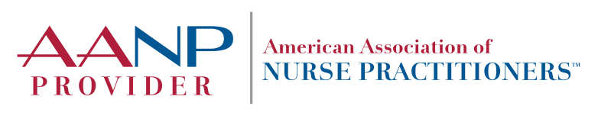

**Commercial Support**There is no commercial support for this activity.

**Disclosure**

It is the policy of AKH Inc. to ensure independence, balance, objectivity, scientific rigor, and integrity in all of its continuing education activities. The author must disclose to the participants any significant relationships with ineligible companies whose products or devices may be mentioned in the activity or with the commercial supporter of this continuing education activity. Identified conflicts of interest are mitigated by AKH prior to accreditation of the activity. AKH planners and reviewers have no relevant financial relationships to disclose.

|  |  |  |
| --- | --- | --- |
| **DISCLOSURES** | | |
| **Name** | **Relationship** | **Commercial Interest** |
| Uran Berisha, Physiotherapist | N/A | Nothing to Disclose |
| Dorothy Caputo, MA, BSN, RN - VP, Healthcare Continuing Education and Operations | N/A | Nothing to Disclose |
| Bernadette Marie Makar, MSN, NP-C, APRN-C – Nurse Planner/Reviewer | N/A | Nothing to Disclose |
| Michele Bielarski, RN – Nurse Planner/Reviewer | N/A | Nothing to Disclose |
| AKH staff and planners | N/A | Nothing to Disclose |
| REVIVE™ staff and planners | N/A | Nothing to Disclose |
| **All of the relevant financial relationships listed for these individuals have been mitigated.** | | |

**Disclosure of Unlabeled Use and Investigational Product**

This educational activity may include discussion of uses of agents that are investigational and/or unapproved by the FDA. Please refer to the official prescribing information for each product for discussion of approved indications, contraindications, and warnings.

**Disclaimer**

This course is designed solely to provide the healthcare professional with information to assist in his/her practice and professional development and is not to be considered a diagnostic tool to replace professional advice or treatment. The course serves as a general guide to the healthcare professional, and therefore, cannot be considered as giving legal, nursing, medical, or other professional advice in specific cases. AKH Inc. specifically disclaim responsibility for any adverse consequences resulting directly or indirectly from information in the course, for undetected error, or through participants misunderstanding of the content.

If you would like to opt out from future communications from AKH please send an email to optout@akhcme.com with your information with "Opt Out" in the subject line.